RockStar typically uses the same default username and password for most of their servers, so try this first:

* **Username:** jimi
* **Password:** hendrix

Try to figure out which port/service would be used for remote system administration, and then using these credentials, attempt to log into the IP that responded to pings from **Phase 1**.

nslookup rollingstone.com

Server: 8.8.8.8

Address: 8.8.8.8#53

Non-authoritative answer:

Name: rollingstone.com

Address: 151.101.0.69

Name: rollingstone.com

Address: 151.101.64.69

Name: rollingstone.com

Address: 151.101.128.69

Name: rollingstone.com

Address: 151.101.192.69

ssh jimi@167.172.144.11 Yes Password: hendrix

cat /etc/hosts

exit

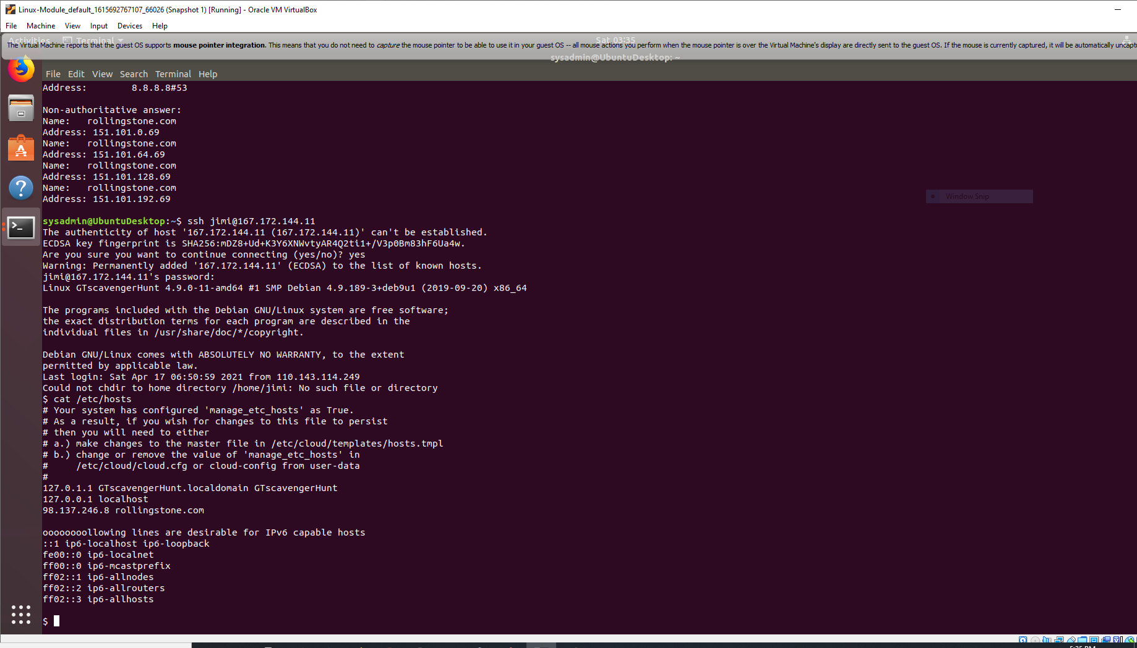

nslookup 98.137.246.8

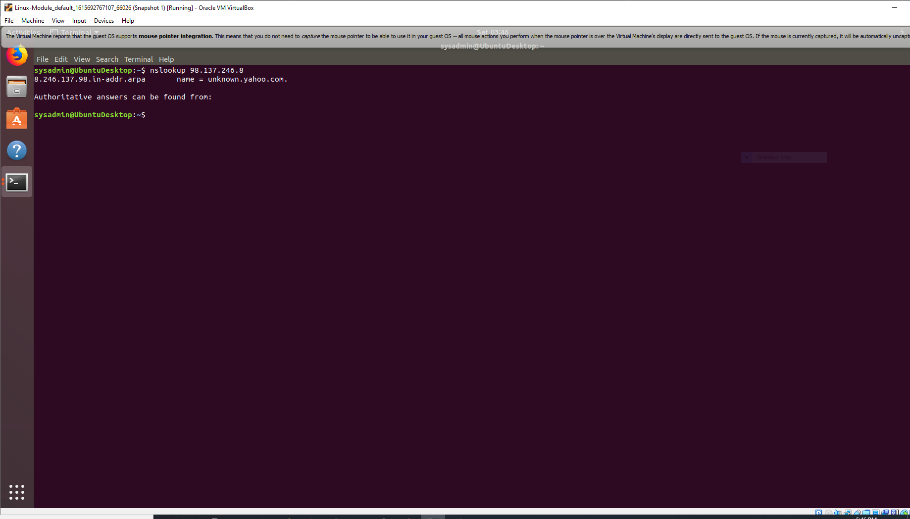

OSI layer is Application Layer